Assessment Schedule – 2014
Mathematics and Statistics: Investigate relationships between tables, equations and graphs (91028)
Evidence Statement
Q | Evidence | Achievement | Achievement with Merit | Achievement with Excellence
ONE  (a)(i) | Table completed | Table correct.
  1 | 4
  2 | 5
  3 | 6
  4 | 7
  7 | 10
(ii) | Graph of A = n + 3  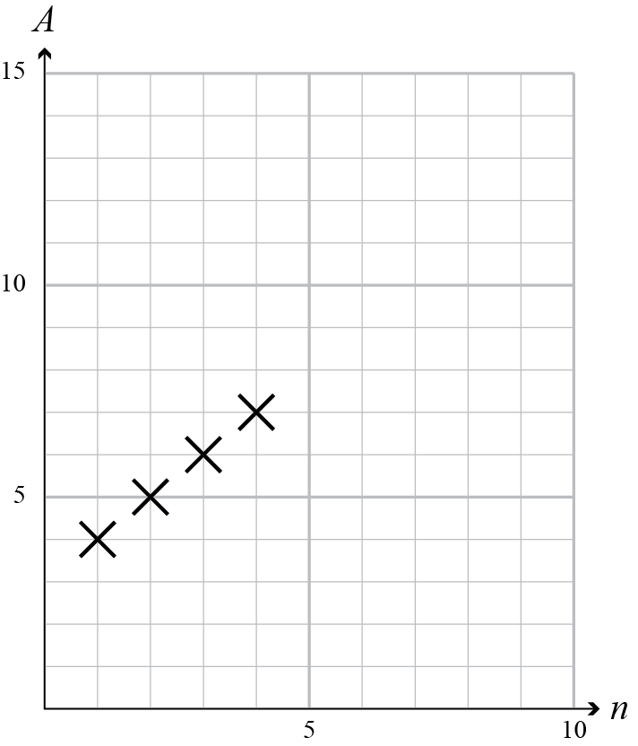 | Correct graph with points joined. | Correct graph with discrete points.
(iii) | A = 3n + 9 | Correct.
(iv) | 54 | Correct.
(b)(i) | Graph y = (x² + 7x) / 2  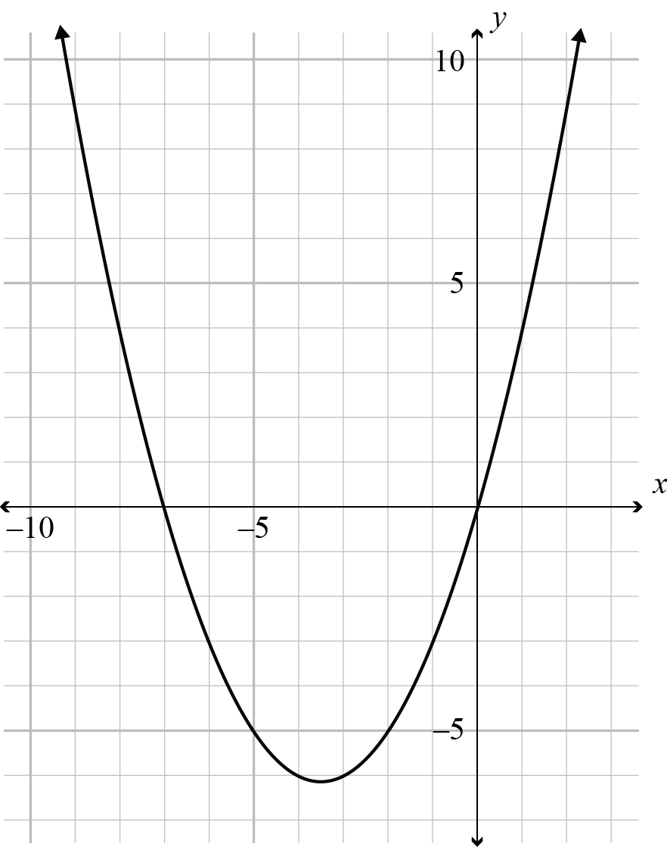 | Graph of x² + 7x | Some errors. | Correct graph.
(ii) | Discrete points – you cannot have fractional number of cans.  First point is (1,4) or No points for n < 1.  There would be no display if you didn’t have any cans, and the number of cans cannot be negative. | One reason. | Either ONE reason with explanation.  OR  TWO reasons without explanation. | Full explanation.

NØ | N1 | N2 | A3 | A4 | M5 | M6 | E7 | E8
No response; no relevant evidence. | Some evidence. | 1 of u | 2 of u | 3 of u | 1 of r | 2 of r | 1 of t | 2 of t

Q | Evidence | Achievement | Achievement with Merit | Achievement with Excellence
TWO  (a)(i) | y = (x – 2)(x + 4) | Some errors in equation. | Equation correct.
(ii) | –4 < x < 2 | ONE section correct  OR correct with minor  errors. | BOTH sections identified.
(b) | y intercept.  The value of the function when  x = 0 | Correct.
(c)(i) | (0.5,–0.25) | ONE coordinate correct. | Correct coordinates.
(ii) | All points would be twice as high as they are now, then reflected in the x-axis.  The parabola would be twice as steep and it would be upside-down. | Some aspect correctly identified. | Incomplete description. | Full description.
(iii) | y = (x – 5)² – (x – 5) + 15  = x² – 11x + 45 | 15 added. | –5 and 15 in equation. | Simplified equation.

NØ | N1 | N2 | A3 | A4 | M5 | M6 | E7 | E8
No response; no relevant evidence. | Some evidence. | 1 of u | 2 of u | 3 of u | 1 of r | 2 of r | 1 of t | 2 of t

Question | Evidence | Achievement | Achievement with Merit | Achievement with Excellence
THREE  (a)(i) | Graph of A = 450 – 15w  As a step function (end points do not need to be open / closed correctly). | Drawn as continuous line. | Discrete graph with dots. | Step function.
(ii) | A = 450 – 15w | Gradient correct. | Equation correct.
(iii) | Graph A = 500 – 20w drawn from w = 10 | Drawn as continuous line. | Discrete graph with dots.
(iv) | 10 | Correct solution.
(v) | y = –20w + 500 | Gradient correct. | Correct equation.
(b) | y = 2^{(x + 1)} – 3 |  | ONE error in equation. | Correct equation.

NØ | N1 | N2 | A3 | A4 | M5 | M6 | E7 | E8
No response; no relevant evidence. | Some evidence. | 1 of u | 2 of u | 3 of u | 1 of r | 2 of r | 1 of t | 2 of t

Cut Scores
 | Not Achieved | Achievement | Achievement with Merit | Achievement with Excellence
Score range | 0 – 6 | 7 – 13 | 14 – 18 | 19 – 24

